Group 50 – Design and Development

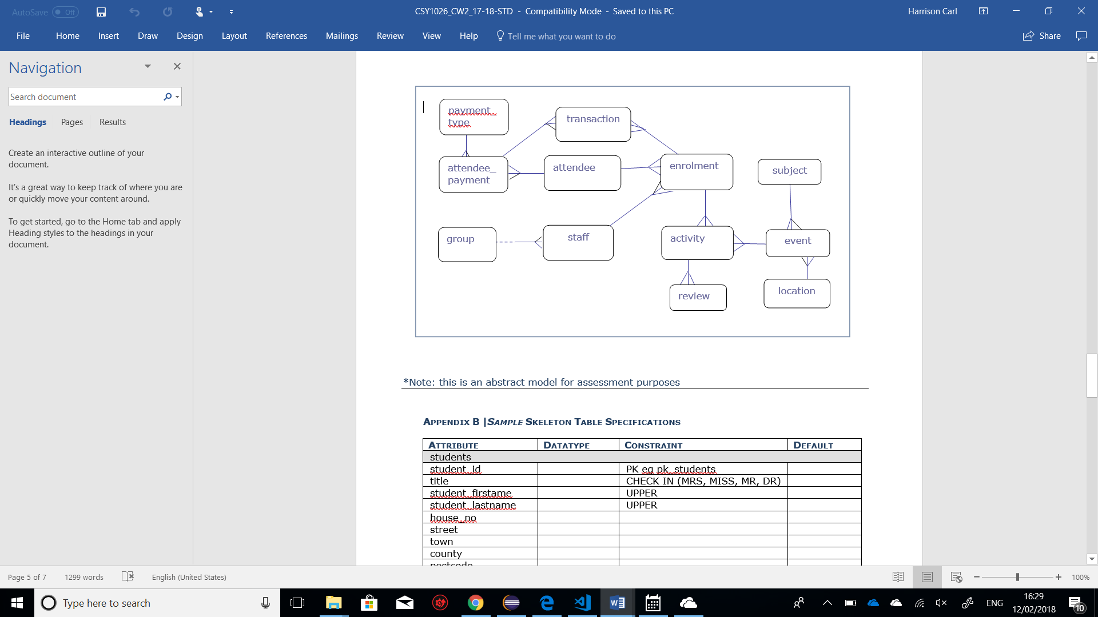



(Bruzac, n.d.)(Worts, n.d.)(Harrison, n.d.)(Matysiak, n.d.)

**subjects**

|  |  |  |  |
| --- | --- | --- | --- |
| **Attribute** | **Datatype** | **Constraint** | **Default** |
| students | | | |
| subject_id | NUMBER(3) | pk_subjects |  |
| subject_title | VARCHAR(20) |  |  |
| subject_category | VARCHAR(15) |  |  |

**locations**

|  |  |  |  |
| --- | --- | --- | --- |
| **Attribute** | **Datatype** | **Constraint** | **Default** |
| students | | | |
| location_id | NUMBER(3) | pk_locations |  |
| location_country | VARCHAR(15) | UPPER | UK |
| location_city | VARCHAR(15) |  |  |
| location_street | VARCHAR(40) |  |  |
| location_house_no | VARCHAR(4) |  |  |
| location_postcode | VARCHAR(8) |  |  |
| location_function | VARCHAR(20) |  |  |
|  |  |  |  |

**events**

|  |  |  |  |
| --- | --- | --- | --- |
| **Attribute** | **Datatype** | **Constraint** | **Default** |
| students | | | |
| event_id | NUMBER(4) | pk_events |  |
| location_id | NUMBER(3) | fk_e_locations NOTNULL |  |
| subject_id | NUMBER(3) | fk_e_subjects NOTNULL |  |
| event_date | DATE |  | TodaysDate |
| event_duration | NUMBER(4,2) |  |  |
| event_title | VARCHAR(15) | UPPER |  |
| event_description | VARCHAR(40) |  |  |
| event_capacity | VARCHAR(10) |  |  |

**payment_types**

|  |  |  |  |
| --- | --- | --- | --- |
| **Attribute** | **Datatype** | **Constraint** | **Default** |
| students | | | |
| payment_type_id | NUMBER(3) | pk_payment_types |  |
| method | VARCHAR(20) |  | VISA |
|  |  |  |  |
|  |  |  |  |
|  |  |  |  |
|  |  |  |  |
|  |  |  |  |
|  |  |  |  |
|  |  |  |  |
|  |  |  |  |
|  |  |  |  |
|  |  |  |  |
|  |  |  |  |
|  |  |  |  |
|  |  |  |  |

**groups**

|  |  |  |  |
| --- | --- | --- | --- |
| **Attribute** | **Datatype** | **Constraint** | **Default** |
| students | | | |
| group_id | NUMBER(4) | pk_groups |  |
| department | VARCHAR(20) |  |  |
| contact_number | CHAR(11) |  |  |
| group_name | VARCHAR(30) |  |  |
|  |  |  |  |
|  |  |  |  |
|  |  |  |  |

**staff**

|  |  |  |  |
| --- | --- | --- | --- |
| **Attribute** | **Datatype** | **Constraint** | **Default** |
| students | | | |
| staff_id | NUMBER(4) | pk_staff |  |
| group_id | NUMBER(4) | fk_s_groups |  |
| title | VARCHAR(3) | CHECK IN (MRS,MISS,MR,DR) | MR |
| staff_firstame | VARCHAR(20) | UPPER |  |
| staff_lastname | VARCHAR(40) | UPPER |  |
| house_no | VARCHAR(4) |  |  |
| street | VARCHAR(20) |  |  |
| town | VARCHAR(20) |  |  |
| county | VARCHAR(20) |  |  |
| postcode | CHAR(6) |  |  |
| country | VARCHAR(20) |  | UK |
| contact_number | CHAR(11) |  |  |
| email | VARCHAR(30) | UNIQUE |  |
| gender | CHAR(1) |  | F |
| date_registered | DATE |  | todaysDate |

**\*attendees**

|  |  |  |  |
| --- | --- | --- | --- |
| **Attribute** | **Datatype** | **Constraint** | **Default** |
| students | | | |
| attendee_id | NUMBER(8) | pk_attendees |  |
| attendee_firstname | VARCHAR2(20) | UPPER |  |
| attendee_lastname | VARCHAR2(20) | UPPER |  |

**attendee_payments**

|  |  |  |  |
| --- | --- | --- | --- |
| **Attribute** | **Datatype** | **Constraint** | **Default** |
| students | | | |
| attendee_payment_id | NUMBER(10) | pk_attendee_payments |  |
| attendee_id | NUMBER(8) | fk_ap_attendees NOTNULL |  |
| payment_type_id | NUMBER(3) | fk_ap_payment_types NOTNULL |  |
| payment_date | DATE |  |  |

**enrolments**

|  |  |  |  |
| --- | --- | --- | --- |
| **Attribute** | **Datatype** | **Constraint** | **Default** |
| students | | | |
| enrolment_id | NUMBER(10) | pk_enrolments |  |
| staff_id | NUMBER(8) | fk_e_staff NOTNULL |  |
| attendee_id | NUMBER(8) | fk_e_attendees NOTNULL |  |
| enrolment_date | DATE |  |  |

**transactions**

|  |  |  |  |
| --- | --- | --- | --- |
| **Attribute** | **Datatype** | **Constraint** | **Default** |
| students | | | |
| transaction_id | NUMBER(8) | pk_transactions |  |
| attendee_payment_id | NUMBER(10) | fk_t_attendee_payments NOTNULL |  |
| enrolment_id | NUMBER(10) | fk_t_enrolments NOTNULL |  |

**activities**

|  |  |  |  |
| --- | --- | --- | --- |
| **Attribute** | **Datatype** | **Constraint** | **Default** |
| students | | | |
| activity_id | NUMBER(4) | pk_activities |  |
| enrolment_id | NUMBER(10) | fk_a_enrolments NOTNULL |  |
| event_id | NUMBER(4) | fk_a_events NOTNULL |  |
| location | VARCHAR2(20) | UPPER |  |
| activity_date | DATE |  |  |

**reviews**

|  |  |  |  |
| --- | --- | --- | --- |
| **Attribute** | **Datatype** | **Constraint** | **Default** |
| students | | | |
| review_id | NUMBER(8) | pk_reviews |  |
| activity_id | NUMBER(4) | fk_r_activities NOTNULL |  |
| review_content | VARCHAR2(200) |  |  |
| review_date | DATE |  |  |
| rate | NUMBER(3) |  |  |

# References

Bruzac, A., n.d. s.l.:University of Northampton.

Harrison, C., n.d. s.l.:University of Northampton.

Matysiak, S., n.d. s.l.:University of Northampton.

Worts, H., n.d. s.l.:University of Northampton.